Title of the publication (12pt TNR Bold, Capital letters, centered)
¹First Author, ²Second Author (10pt TNR, bold, italic, centered)
¹First Author’s address: institution name, street and number, ZIP code, city, country,
²Second Author’s address: institution name, street and number, ZIP code, city, country,
(Corresponding author’ email) e-mail: email@email.email (10pt TNR, normal, centered)

Received: DD-MM (do not edit!) | Accepted: DD-MM (do not edit!)
ABSTRACT
These instructions give you basic guidelines for preparing camera-ready (CR) manuscript. Please, use this template for your work. Abstract of the paper should have approximately 150-200 words. Do not cite any references, figures, tables or equations in this section. Avoid unfamiliar terms, acronyms, abbreviations, symbols or define them if there is no choice. Abstract font: TNR 9pt, normal, justified
Keywords: 3-6 significant keywords
1. INTRODUCTION (First level headings: TNR 10pt, capital letters, justified)
The paper should be written in English language. Use „doc” or docx format. Prepare your CR paper in full-size format on B5 paper (182x257 mm). Margins: top = 35 mm, bottom: 20 mm, left and right = 15 mm. The manuscript should be no longer than 10 pages. The paper should have the following sections after Introduction: Materials and Methods, Results, Discussion, (or: Results and Discussion), Conclusions, Acknowledgement (if necessary), References.
Text formatting: TNR 10 pts, normal, single line, justified. Please avoid using Enter to create blank lines between paragraphs.
Literature citations need to be numbered in their order of appearance written in square brackets. Recent studies show that a quite effective and promising method is to combine MW with other processes and/or materials, such as oxidants and catalysts [1].
Bulleted list:
- Item 1
- Item 2
- Item 3
Numbered list:
- Item 1
- Item 2
- Item 3
Numbered list:
- Item 1
- Item 2
- Item 3
Numbered list:
- Item 1
- Item 2
- Item 3
Numbered list:
- Item 1
- Item 2
- Item 3
2. Materials and methods
English language text. English language text. English language text. English language text. English language text. English language text. English language text. English language text. English language text. English language text. English language text. English language text. English language text. English language text.
2.1. Materials (For second level headings: TNR 10 pts, bold, justified)
English language text. English language text. English language text. English language text. English language text.
2.2. Equations
Please, do not use the old, outdated version of Microsoft Equation Editor 3 in the insert object menu; use the new built in equation editor instead. The equations should be numbered in parentheses flush with the right margin, as in (1). Use (1), except at the beginning of a sentence: Equation (1) is...
$$a+b=c?$$ | (1)
English language text. English language text. English language text. English language text. English language text. English language text.
3. results and discussion
English language text. English language text. English language text. English language text. English language text. English language text. English language text.
3.1. Figures, graphs and tables
Use abbreviations Fig. 1 or Tab. 1, even at the beginning of a sentence.
Figures:
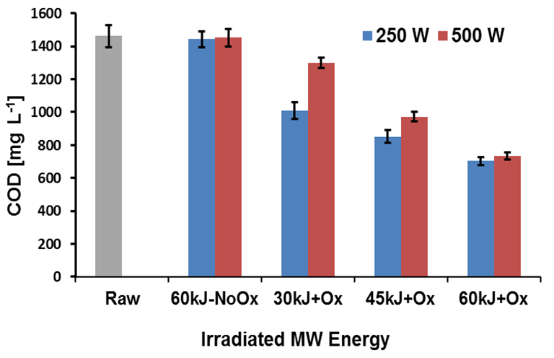
Figure 1. COD change as function of MW energy (TNR 8pts, bold, italic, centered)
Caption is after figure.

English language text. English language text. English language text. English language text. English language text. English language text. English language text. English language text.

Tables:
Caption is before table.
Table 1. Calculated resistances of different pretreated juice types (TNR 8pts, bold, italic, centered)
Control | A
PSE enzyme | B
Trenolin enzyme, 4 days 6 °C | C
Trenolin enzyme, 1 day 25 °C | D

Illustrations, figures, and tables are placed within the text at the appropriate points.
Figures, Schemes, and Tables need to be numbered in their order of appearance.

4. conclusions
English language text. English language text. English language text. English language text. English language text. English language text.

references
Refer simply to the reference number, as in [1]. Use Ref. [1] or Reference [1] at the beginning of a sentence: Ref. [1] contains the best... Literature citations need to be numbered in their order of appearance.

[1] A. Hošovský, M. Havran, Dynamic Modelling of One Degree of Freedom Pneumatic Muscle Based Actuator for Industrial Applications, Technical Gazette, 19 (3) (2012), pp. 673-681.
[2] R. M. Enoka, Neuromechanics of Human Movement, 4th Edition, Human Kinetics, Champaign, IL, 2008
[3] K. Bharadwaj, K. W. Hollander, C. A. Mathis, T. G. Sugar, Spring Over Muscle Actuator for Rehabilitation Devices, 26th Annual International Conference of the IEEE EMBS, San Francisco, CA, USA, September 1-5 2004, pp. 2726-2729.

PLEASE, DO NOT INCLUDE THIS PAGE WHEN SUBMITTING THE FINAL DRAFT!

General instructions and considerations for formatting and submitting

- The formatting of the articles according to this template is mandatory for all Authors! Articles that do not meet the formal criteria will be automatically rejected and sent back to Authors for reformatting.

- Please do not implement any kind of modifications regarding the formatting of different sections, subsections, captions, etc. unless it is absolutely necessary. Do not increase or decrease the font size or spacing!

- Please do not edit the footing or heading of the template!

- All the authors that appear on the Manuscript must be properly listed in the submission system as well in the order of appearing (name, E-mail, affiliation, ORCiD number (if available))! In case the list of authors is incomplete or incorrect in the submission system, the different indexing databases or scientific metric services will not be able to associate the paper with the given author!

The Editorial Team of Analecta Technica Szegedinensia is not obliged to fill in or correct the incomplete / incorrect data in any way!

- Make sure that the Funding information is correctly recorded during the submission (if applicable). If the funding data is not registered or can not be found in the Crossref database, please indicate the funder agency and grant number in the Metadata section under the Supporting Agencies option!

- Once an issue is published, it is not possible to change any data of the submitted Manuscripts!

The Journal does not have the capacities nor the obligation to correct and/or complete the incorrect and/or missing information regarding these subjects!
In no event shall the journal be liable for issues arising from incorrectly or incompletely provided information.
PLEASE, DO NOT INCLUDE THIS PAGE WHEN SUBMITTING THE FINAL DRAFT!

